Relax Inc. Take Home Challenge

Jeffrey Jex

# What factors affect user adoption

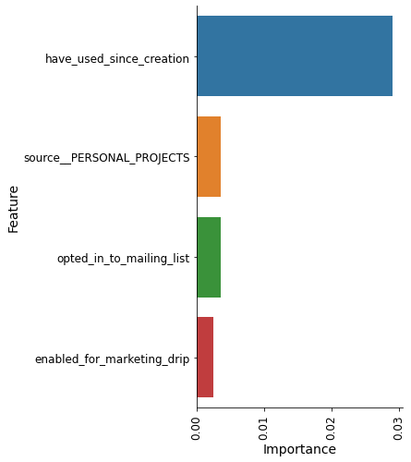

Figure A: Feature importance from Random Forest model. Fig 1B shows a detailed view of the 2-5th most important features.

I added a feature called “creation_minus_last_active_date_as_days”. This shows the number of days between the users last login and their account creation. Users who never logged in are set at ‘0’. This is the most important feature by far! The next 4 most important features are: source is personal projects, and if they are on the mailing list or marking drip.

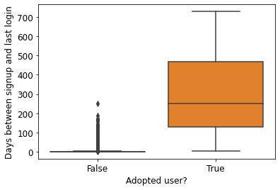

The more time a user has been enrolled, the more likely they are to be adopted.

Here’s my interpretation: people who have used our tools for a greater length of time are also more likely to have been adopted. “Adopted user” may not be the best metric, I’d recommend looking to see how many weeks a user is adopted (i.e. using the product > 3 times in 7 days, for consecutive 7 day windows).

**Method**: I used a random forest classifier to determine feature importance, after engineering the features. See github code for more details.